EMOTION RECOGNITION BY SPEECH
A Report for SE project

By:-
Somesh Bachani 18SCSE1180018

Abstract

In human machine interface application, feeling recognition from the speech signal has been an exploration topic for several years. to spot the emotions from the speech signal, several systems are developed. During this project report speech feeling recognition supported the previous technologies that use completely different classifiers for the feeling recognition is reviewed. Speech has many characteristic options like naturalness and potency, that makes it a beautiful interface medium. it's attainable to precise emotions and attitudes through speech. to acknowledge feeling through speech varied speech options were extracted. supported these speech options Classification of the emotions has been done and also the classification performance of the model. Here feeling recognition is completed for various emotions like neutral, happy, sad, dissatisfaction anger, and fear. The classification performance relies on extracted options. reasoning concerning the performance and limitation of speech feeling recognition systems supported the various classifiers are mentioned.

Introduction

Emotion Recognition with MFCC and DTW is deployed to see the emotion of the speaker from his acted speech. The speech signal given by the speaker is compared with the information that consists of assorted sentences that outline the varied emotions of the language.

Motivation:

Emotion Recognition is a crucial side in today's world whereas machine learning is currently trending and growing technology. It involves the process of the signaling and also the analysis of the emotion by extracting the features of the input voice signal.

Scope of Project:
As mentioned earlier, emotion Recognition is a known basic step concerned with machine learning and deep learning. We have a tendency to have an interest in training the machines in such some way that they'll give service that is nearly as good as that provided by humans and a high efficiency of performance.

Methodology:
In order to determine the emotion of the received speech signal, we have to obtain various features like energy, power spectral density (PSD) etc. of the signal and compare it with the recorded database. We are achieving this using MFCC.

Purpose

Directly or indirectly, you're forever involved with audio. Your brain is endlessly processing and understanding audio information and providing you with data regarding the surroundings. Speech process and synthesis by analysing the emotion of speech helps in classification behaviour of the agent. emotion recognition from the speaker’s speech is extremely tough due to the subsequent reasons: In differentiating between varied emotions that explicit speech options are additional helpful isn't clear. due to the existence of the various sentences, speakers, speaking designs, speaking rates and accosting variability was introduced, due to that speech options get directly affected. a similar vocalization might show totally different emotions. every feeling might correspond to the various parts of the spoken vocalization. so it's terribly tough to differentiate these parts of vocalization. Another downside is that feeling expression is looking at the speaker and his or her culture and setting. Because the culture and setting gets amended, the speaking vogue additionally gets amendment, that is another challenge before the speech feeling recognition system. The analysis of the speech feeling recognition system relies on the extent of naturalness of the sound/speech that is employed as AN input to the speech feeling recognition system. If the inferior speech is employed as AN input to the system then incorrect conclusions could also be drawn. The speech as AN input to the speech feeling recognition system might contain the $64000 world emotions or the acted ones. it's additional sensible to use information that's collected from the $64000 life things. Speech feeling recognition is one among the most recent challenges in the speech process. particularly within the field of security systems a growing interest may be discovered throughout the last year. Besides, the detection of lies, video games and medical specialty aid are usually claimed as more situations for feeling recognition. The most goal of this project is to create a straightforward yet complete representative feeling recognition system for endless speech with the assistance of speech feature extraction methodology and an acceptable classifier to boost its detection accuracy.

Motivations and scope

The information in speech signals is really depicted by the short term amplitude spectrum of the speech wave. This permits us to extract features supporting the short term amplitude spectrum from speech (phonemes). The basic issue of speech recognition is that the speech signal is extremely variable because of completely different speakers, NT speaking rates, contents and acoustic conditions. The feature analysis element of an ASR system plays an important role within the overall performance of the system. The speech process will be performed at completely different 3 levels. Amplitude process considers the anatomy of the human sensory system and method signal within the variety of tiny chunks referred to as frames. In sound level process, speech phonemes square measure non inheritable and processed. Though it's not possible to accurately compare recognition accuracy from this study to different studies owing to various information sets used, the strategies enforced here square measure are extraordinarily promising. Previous studies have neglected to filter out male and feminine speakers. This project shows that there's important profit in doing thus. Our strategies are fairly correct at recognizing emotions in females and every one of the speakers. Our project shows that options derived from agitated emotions like happiness, elation and interest have similar properties, as do those from additional subdued emotions like despair and disappointment. Hence, ‘agitated’ and ‘subdued’ feeling categories will include these narrower emotions. This can be particularly helpful for invigorating gestures of avatars in virtual worlds. This project centered on 2-way classification. The performance of those strategies ought to be evaluated for multi-class classification (using multi-class SVM and K-Means. MFCCs square measure widely utilized in speech recognition systems and additionally carry emotional data. Existing speech recognition systems might be changed to sight emotions further.

Literature Review
The overall steps involved in recognition of emotion from the speech are as shown below:
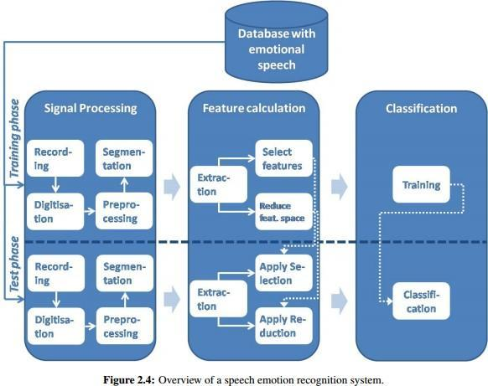

Signal Processing:
Signal processing is an enabling technology that encompasses the fundamental theory, applications, algorithms, and implementations of processing or transferring information contained in many different physical, symbolic, or abstract formats broadly designated as signals. It uses mathematical, statistical, computational, heuristic, and linguistic representations, formalisms, and techniques for representation, modeling, analysis, synthesis, discovery, recovery, sensing, acquisition.

Voice Recognition Algorithms:
A voice analysis is done after taking an input through a microphone from a user. The design of the system involves manipulation of the input audio signal. At different levels, different operations are performed on the input signal such as Pre-emphasis, Framing, Windowing, Mel Cepstrum analysis and Recognition (Matching) of the spoken word. The voice algorithms consist of two distinguished phases. The first one is training sessions, whilst, the second one is referred to as operation session or testing phase
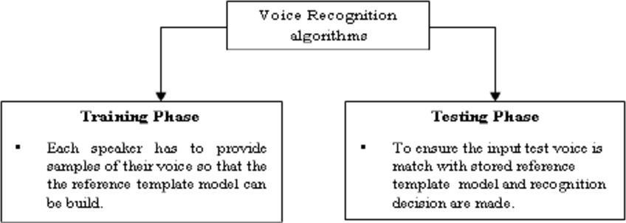

Mel Frequency Cepstral Coefficients (MFCC Feature Extraction):
In sound processing, the Mel-frequency cepstrum (MFC) is a representation of the short-term power spectrum of a sound, based on a linear cosine transform of a log power spectrum on a nonlinear Mel scale of frequency.

Mel-frequency cepstral coefficients (MFCCs) are coefficients that collectively make up an MFC. They are derived from a type of cepstral representation of the audio clip (a nonlinear "spectrum- of-a- spectrum").
The difference between the cepstrum and the mel- frequency cepstrum is that in the MFC, the frequency bands are equally spaced on the mel scale, which approximates the human auditory system's response more closely than the linearly-spaced frequency bands used in the normal cepstrum.
There are 13 mel frequency cepstral coefficients. The Mel scale relates perceived frequency, or pitch, of a pure tone to its actual measured frequency. Humans are much better at discerning small changes in pitch at low frequencies than they are at high frequencies. Incorporating this scale makes our features match more closely what humans hear.
The formula for converting from frequency to Mel scale is:
To go from Mel's back to frequency:

Dynamic Time Warping:
In time series analysis, dynamic time warping (DTW) is an algorithm for measuring similarity between two temporal sequences which may vary in speed. For instance, similarities in walking could be detected using DTW, even if one person was walking faster than the other, or if there were accelerations and decelerations during the course of an observation. DTW has been applied to temporal sequences of video, audio and graphics data — indeed, any data which can be turned into a linear sequence can be analyzed with DTW. A well- known application has been automatic speech recognition, to cope with different speaking speeds. Other applications include speaker recognition and online signature recognition. Also, it is seen that it can be used in partial shape matching applications.
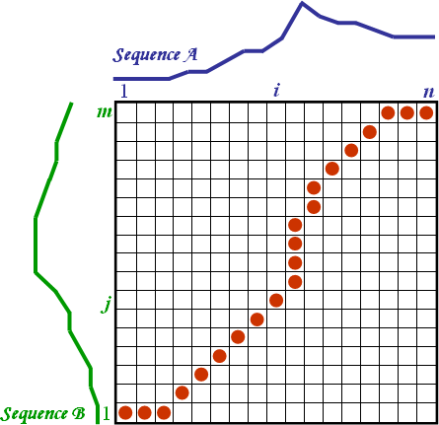

In general, DTW is a method that calculates an optimal match between two given sequences (e.g. time series) with certain restrictions. The sequences are "warped" nonlinearly in the time dimension to determine a measure of their similarity independent of certain non-linear variations in the time dimensions. This sequence alignment method is often used in time series classification. Although DTW measures a distance-like quantity between two given sequences, it doesn't guarantee the triangle inequality to hold.

In addition to a similarity measure between the two sequences, a so-called "warping path" is produced, by warping according to this path the two signals may be aligned in time. The signal with an original set of points
X (original), Y(original) is transformed to X(warped), Y (original).

Design Methodology, Software and Hardware Support

Block diagram:

The basic block diagram of our project is as follows:

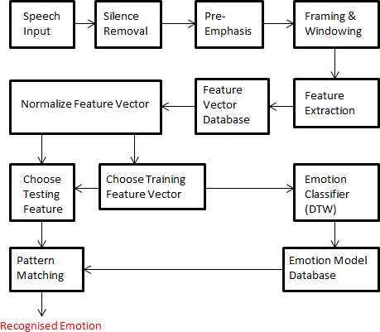

Software used: MATLAB

Steps to be followed for simulation in MATLAB:

Steps to be followed for simulation in MATLAB R2013b:

1. Open MATLAB R2013

2. Download Voice box Toolbox for MATLAB

3. Read .wav files from the input given by user

4. Create a download database for the Emotion Recognition from English Speech.

5. Write a program for calculation of the mel frequency cepstral coefficients of the recorded database as well as for the input signal.

6. Write a program which assigns the coefficients the sentences and their respective emotions.

7. Write a program to calculate the time warping of the Mel frequency cepstral coefficients of the input signal with that of the coefficients of the recorded database.

8. Depending on the result of these comparisons, display the emotion.

9. For determining the accuracy, write a program to calculate the confusion matrix.

Database Details

Corpus design:
We have used Surrey Audio-Visual Expresses emotion (SAVEE) DatabaseThe SAVEE info was recorded from four native English male speakers (identified as DC, JE, JK, and KL), postgraduate students and researchers at the University of Surrey aged from twenty seven to thirty one years.
Emotion has been represented psychologically in separate categories: anger, disgust, fear, happiness, disappointment and surprise. This is often supported by the society studies of ekman and studies of automatic feeling recognition cared-for specialise in recognizing these. we tend to adscititious neutral to produce recordings of seven feeling classes. The text material consisted of fifteen sentences per emotion.This results for a .total of a hundred and twenty utterances per speaker, for example:

Anger: who licensed the unlimited expense account?
Disgust: Please take this dirty table artifact to the cleaners on behalf of me.
Fear: decision associate automobile for medical help.
Happiness: Those musicians harmonize wondrous.
Sadness: The prospect of curbing defrayment is an unpleasant one for any governor.
Surprise: The carpet cleaners shampooed our oriental carpet.
Neutral: the simplest thanks to learn is to resolve additional issues.
The distribution includes an entire list of sentences.

References
- Voice Recognition Algorithms using MelFrequency Cepstral Coefficient(MFCC) and Dynamic Time Warping (DTW) Techniques, LindasalwaMuda, MumtajBegamandI. Elamvazuthi.
- http://www.ee.ic.ac.uk/hp/staff/dmb/voicebox/voicebox.html
- http://wearables.cc.gatech.edu/paper_of_week/DTW_myths.pdf
- https://www.psb.ugent.be/cbd/papers/gentxwarper/DTWalgorithm.html
- http://www.phon.ox.ac.uk/jcoleman/old_SLP/Lecture_5/DTW_explanation.ht ml
- http://www-db.deis.unibo.it/courses/SI-M/slides/04.5.TimeSeries2.pdf
- https://www.vocal.com/speech-recognition
- http://staffwww.dcs.shef.ac.uk/people/S.Wrigley/com326/sym.html
- https://lemonzi.files.wordpress.com/2013/01/dtw.pdf
- http://kahlan.eps.surrey.ac.uk/savee/
- http://practicalcryptography.com/miscellaneous/machine-learning/guide- mel-frequency-cepstral-coefficients-mfccs/
- Santosh Chapaneri , ”Spoken digits recognition using weighted MFCC and improved features for Dynamic time Warping” , International Journal of Computer Applications, vol.40,pp.975, Feb 2012.
- http://in.mathworks.com/matlabcentral/fileexchange/24583-mirtoolbox

